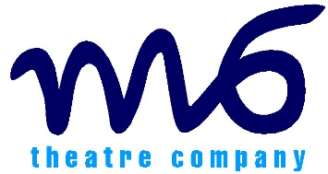
The Incident
Teacher Evaluation Form

M6’s projects are evaluated to assess and provide evidence of impact for a variety of stakeholders. To help us do that, we would appreciate it if you could complete and return this short form as soon as possible after our visit to your school.

Name of school: Year group:

Contact person & email: No. of students:

Date of workshop: No. of adults:

How would you rate The Incident workshop?

Excellent Good Average Poor

Please provide further comments on your rating.

Please describe how your students responded to the film and discussion?

Did your students offer any comments that indicate the session has assisted their understanding of healthy relationships?

How important and effective are these fully funded, creative interventions to schools/youth settings?

Any other comments.

Do you plan on delivering this resource yourself/recommending to a colleague?

Thank you for your support. Please return the completed form in the envelope provided or to a member of the team.

